INTERFACE DESIGN
for
VaagBanda
Smart Mobile Expense-Splitting Application

Version 1.0
Prepared by CyberSquadNp
Dongshin University
Glocal Autonomous Major College
May 2026
Design Phase – Interface Design Document
Sequence Diagram-Activity Diagarm

1. Introduction
This document contains UML analysis models for VaagBanda. All diagrams have been revised to reference the actual database design, which uses a dual-database architecture: AuthDB for authentication and identity management, and SharedExpenseDB for all application data (groups, expenses, splits, settlements, notifications, and categories).
The diagrams follow UML notation as described in Dennis, Wixom & Roth (8th Edition, Chapters 4–6) and Sommerville (10th Edition, Chapter 5). Each diagram includes green annotations showing the specific database tables and queries involved in each interaction.

1.1 Database Architecture Summary
The VaagBanda database uses two separated databases for security and separation of concerns:
Database | Tables | Purpose
AuthDB | Users, Sessions, BiometricAuth, PasswordReset | Handles user identity, login credentials, session tokens, biometric preferences, and password recovery. Completely isolated from business logic.
SharedExpenseDB | Groups, GroupMembers, Expenses, Splits, Settlements, Notifications, Categories | Stores all application data. Balance is derived in real-time: SUM(Splits.amount_owed) - SUM(Settlements.amount) per user. No cached balance table.

1.2 References
- Dennis, A., Wixom, B. H., & Roth, R. M. – Systems Analysis and Design, 8th Edition
- Sommerville, I. – Software Engineering, 10th Edition
- VaagBanda Database Design Document v1.0 – CyberSquadNp
- VaagBanda SRS v1.0 (IEEE 830 format) – CyberSquadNp
- VaagBanda Architecture

2 Sequence Diagrams
The following sequence diagrams model the time-ordered interactions for three key system flows. Each diagram now includes five participants that map to the dual-database architecture: the User, Mobile App, API Server, AuthDB (for authentication), and SharedExpenseDB (for application data). Green annotations on each database interaction show the specific table and query involved.

2.1 Sequence Diagram: Add Expense
This diagram shows the complete flow when a user adds a new expense. The API Server first validates the session token against AuthDB.Sessions, then verifies group membership in SharedExpenseDB.GroupMembers and validates the category in SharedExpenseDB.Categories. Upon validation, a database transaction inserts into three tables: Expenses (the expense record), Splits (one row per participating member with their amount_owed), and Notifications (one row per participant). The balance is never stored as a cached value; it is derived at query time from SUM(Splits.amount_owed) minus SUM(Settlements.amount).
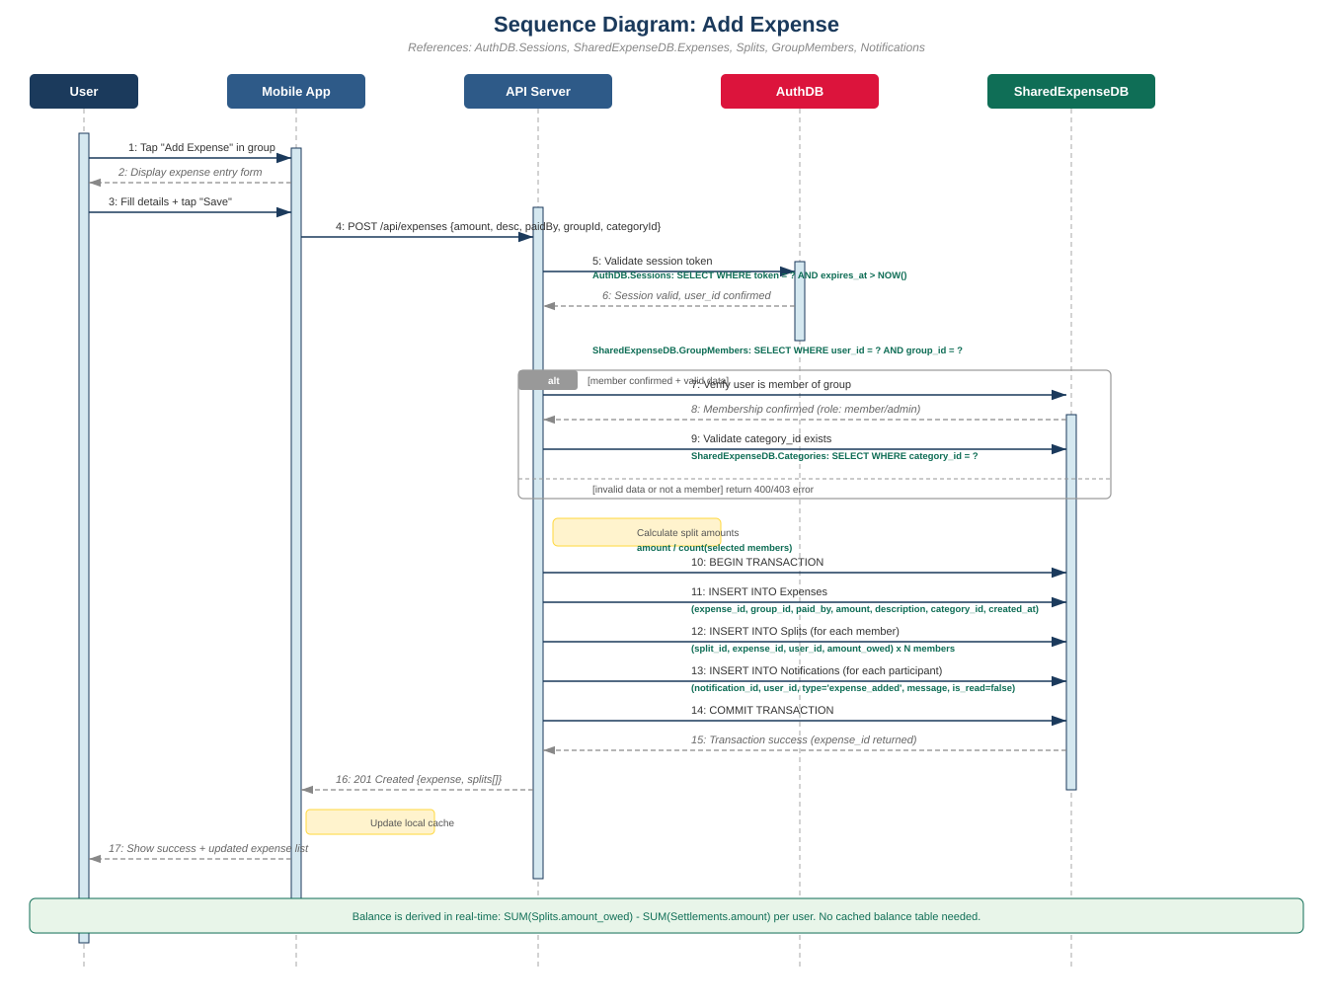
Figure 3.1 – Sequence Diagram: Add Expense (with database references)

2.2 Sequence Diagram: User Registration
This diagram shows the registration flow referencing AuthDB tables exclusively. The API Server checks email uniqueness in AuthDB.Users, hashes the password, and inserts a new user record. It then creates a session in AuthDB.Sessions with an expiry date for automatic logout, and initializes a biometric auth record in AuthDB.BiometricAuth (storing only an enabled/disabled flag, never raw biometric data). A welcome email is dispatched asynchronously. The alt fragment shows the duplicate email path returning a 409 Conflict response.
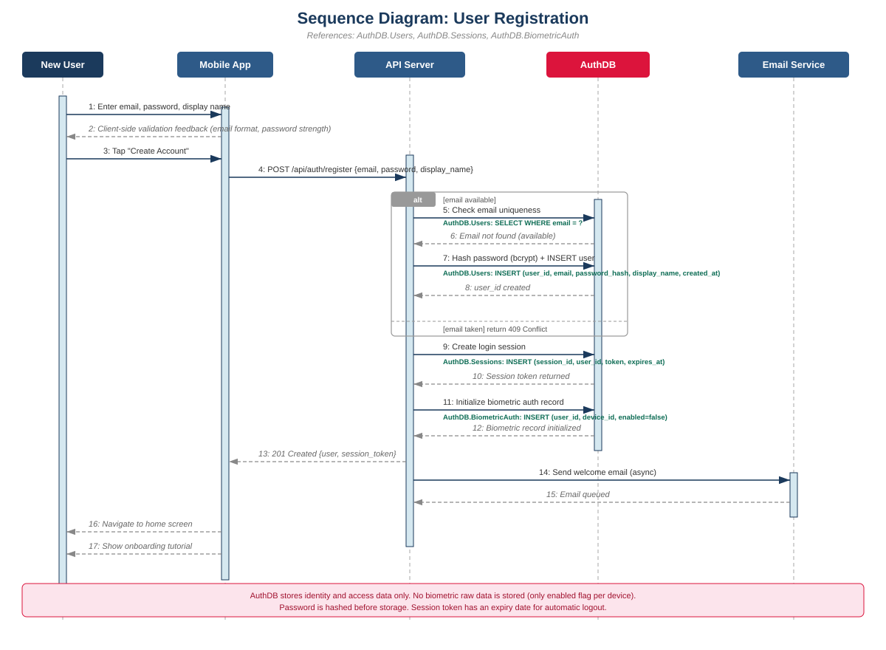
Figure 3.2 – Sequence Diagram: User Registration (with AuthDB references)

2.3 Sequence Diagram: Record Settlement
This diagram shows the settlement recording flow. The API Server calculates the debtor’s current outstanding balance by querying SharedExpenseDB: SUM(Splits.amount_owed) minus SUM(Settlements.amount). After validating that the settlement amount does not exceed the balance, a database transaction inserts into Settlements (with payer_id, payee_id, amount, method, and settled_at) and Notifications (alerting the creditor). The system does not transfer any money; it only records that an external payment occurred.
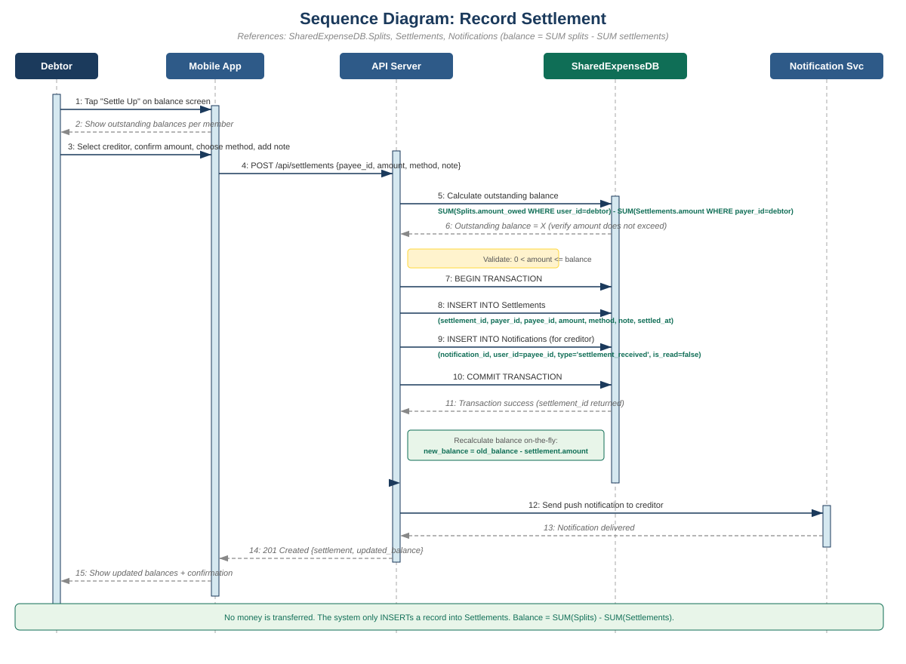
Figure 3.3 – Sequence Diagram: Record Settlement (with database references)

3 Activity Diagrams
The following activity diagrams use swimlanes to show responsibility across system tiers. The server swimlane now explicitly shows the Pipe-and-Filter pipeline stages (Input Filter, Auth Filter, Business Logic, Data Access, Output Filter). The database swimlane shows both AuthDB and SharedExpenseDB operations with specific table references.

3.1 Activity Diagram: Add Expense Flow
This diagram models the complete Add Expense workflow across three swimlanes: User/Mobile App, API Server (showing the pipe-and-filter stages), and the database tier. Key decision points include whether the user attaches a receipt (optional OCR path) and whether the input data passes validation. The database swimlane shows queries to AuthDB.Sessions for session validation, SharedExpenseDB.GroupMembers for membership verification, and INSERT operations into Expenses, Splits, and Notifications tables.
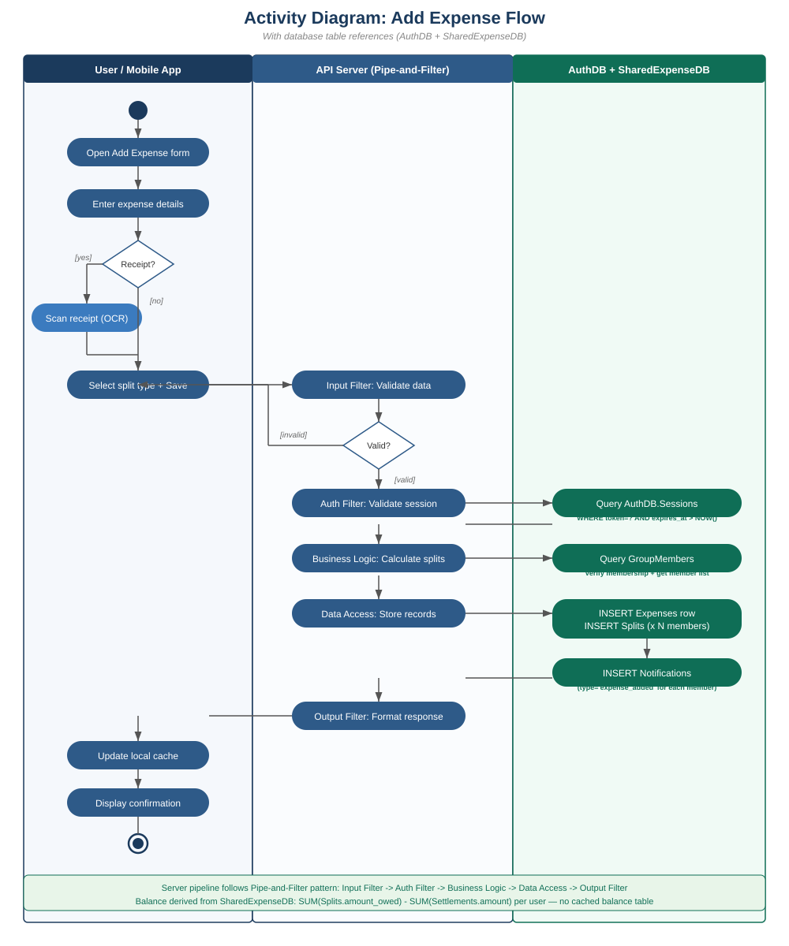
Figure 4.1 – Activity Diagram: Add Expense (with pipe-and-filter and database references)

3.2 Activity Diagram: Record Settlement Flow
This diagram models the settlement recording workflow. The database swimlane shows the balance calculation query (SUM Splits minus SUM Settlements), the validation decision (amount must be positive and not exceed the outstanding balance), the transactional INSERT into Settlements and Notifications, and the COMMIT. The server sends a push notification to the creditor after the transaction succeeds.
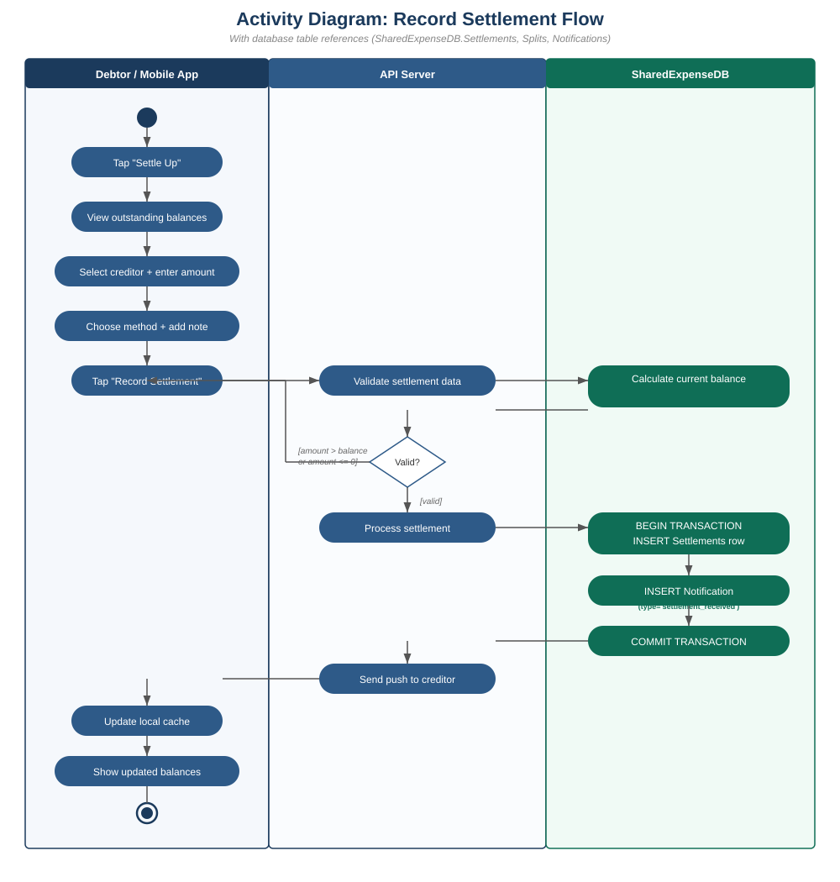
Figure 4.2 – Activity Diagram: Record Settlement (with database references)

6. Diagram-to-Database Traceability
The following table maps each diagram interaction to the specific database table and operation it references. This traceability ensures that every interaction shown in the analysis models has a corresponding backing structure in the database design.
Diagram | Interaction | Database | Table + Operation
Add Expense (Seq) | Validate session | AuthDB | Sessions: SELECT WHERE token=? AND expires_at > NOW()
Add Expense (Seq) | Check membership | SharedExpenseDB | GroupMembers: SELECT WHERE user_id=? AND group_id=?
Add Expense (Seq) | Validate category | SharedExpenseDB | Categories: SELECT WHERE category_id=?
Add Expense (Seq) | Store expense | SharedExpenseDB | Expenses: INSERT (expense_id, group_id, paid_by, amount, description, category_id)
Add Expense (Seq) | Store splits | SharedExpenseDB | Splits: INSERT (split_id, expense_id, user_id, amount_owed) x N members
Add Expense (Seq) | Notify members | SharedExpenseDB | Notifications: INSERT (type=‘expense_added’) for each participant
Registration (Seq) | Check email | AuthDB | Users: SELECT WHERE email=?
Registration (Seq) | Create user | AuthDB | Users: INSERT (user_id, email, password_hash, display_name, created_at)
Registration (Seq) | Create session | AuthDB | Sessions: INSERT (session_id, user_id, token, expires_at)
Registration (Seq) | Init biometric | AuthDB | BiometricAuth: INSERT (user_id, device_id, enabled=false)
Settlement (Seq) | Get balance | SharedExpenseDB | Splits + Settlements: SUM(amount_owed) - SUM(amount)
Settlement (Seq) | Record settlement | SharedExpenseDB | Settlements: INSERT (settlement_id, payer_id, payee_id, amount, method, settled_at)
Settlement (Seq) | Notify creditor | SharedExpenseDB | Notifications: INSERT (type=‘settlement_received’)

5. Balance Calculation Design Note
An important design principle reflected in all diagrams is that VaagBanda does not store cached balance values anywhere in the database. Instead, the balance is always derived in real-time from the source data, as documented in the Database Design Document:
Outstanding Balance = SUM(Splits.amount_owed WHERE user_id = ?) - SUM(Settlements.amount WHERE payer_id = ?)
This approach has several advantages documented in the Database Design Document:
- No stale cached balances that could become inconsistent with the source data.
- Full audit trail is preserved in the Splits and Settlements tables.
- The balance can be recalculated at any time from raw data, supporting data integrity verification.
- Partial payments are handled naturally because each settlement record reduces the derived balance independently.
This design decision is reflected in the sequence diagrams (where the balance query appears as a derived calculation, not a table lookup) and in the activity diagrams (where no “update balance table” step exists).

— Interface designV1 completed —

